
Belmont City College

YEAR 11 CHEMISTRY 2ACHE

TEST 2
Solutions and Stoichiometry

Time: 1 hour

MULTIPLE CHOICE QUESTION BOOKLET

PLEASE DO NOT TURN THE PAGE UNTIL INSTRUCTED TO DO SO

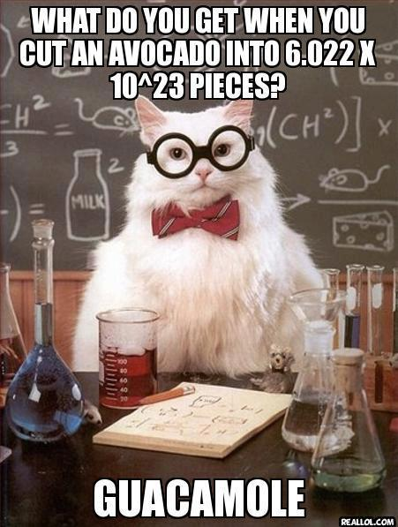

Multiple choice section – Answer on the answer sheet provided

- A small amount of copper sulfate solid was added to a solution of copper sulfate. The crystal did not dissolve. From this observation , what can be concluded about the original copper sulphate solution?

  - The solution was unsaturated.
  - The solutions is super-saturated.
  - The solution was saturated.
  - It was a dilute solution.

- Pure water boils at 100·0° and 101·3 kPa pressure. The table below shows the boiling point when 1·00 mol of different solutes are added to a litre of water
Solute | Boiling Point (°C)
KBr | 101·0
ZnBr₂ | 101·5
AlBr₃ | 102·0

Which statement best explains the trend illustrated in the table?

  - Dissolving solute particles change the properties of the solvent.
  - The solutes lower the vapour pressure.
  - Different solutes have different abilities to raise the boiling point.
  - The greater the concentration of the solute particles, the higher the boiling point.

- How many oxygen atoms are present in one formula unit of calcium hydroxyapatite – [Ca₃(PO₄)₂]₃.Ca(OH)₂ ?

  - 26
  - 14
  - 10
  - 2

- Which of the following is not an assupmtion of the kinetic theory of gases?

  - Gasses consist of tiny particles.
  - All collisions are perfectly elastic
  - Attractive or repulsive forces between particles are significant.
  - The average kinetic energy of gas particles increases as the temperature increases.

- Which of the following has the greatest concentration of solute particles.

  - 1·0 mol L⁻¹ NaCl
  - 1·0 mol L⁻¹ C₁₂H₂₂O₁₁ (sucrose)
  - 1·0 mol L⁻¹ Mg(NO₃)₂
  - 1·0 mol L⁻¹ Na₃PO₄

- How many moles of nitrate ions are present in 2·4 L of a 1·2 mol L⁻¹ solution of magnesium nitrate?

  - 1.44
  - 2·88
  - 5.76
  - 8·64

- Which of the following correctly shows what happens to the colligative properties when the concentration of a solute is increased?
 | Vapour pressure | Boiling Point | Melting Point
a. | Decreases | Decreases | Decreases
b. | Decreases | Increases | Decreases
c. | Increases | Increases | Decreases
d. | Increases | Increases | Increases

- 50·0 mL of a 2·5 mol L⁻¹ is diluted by adding water so that its volume increases to 200·0 mL. Which of the following is the new concentration of the solution?

  - 10·0 mol L⁻¹
  - 5·0 mol L⁻¹
  - 1·25 mol L⁻¹
  - 0·625 mol L⁻¹

- The chart below shows the heating curve for substance X. Which section of the graph indicates that both the solid and the liquid form of substance X are present?

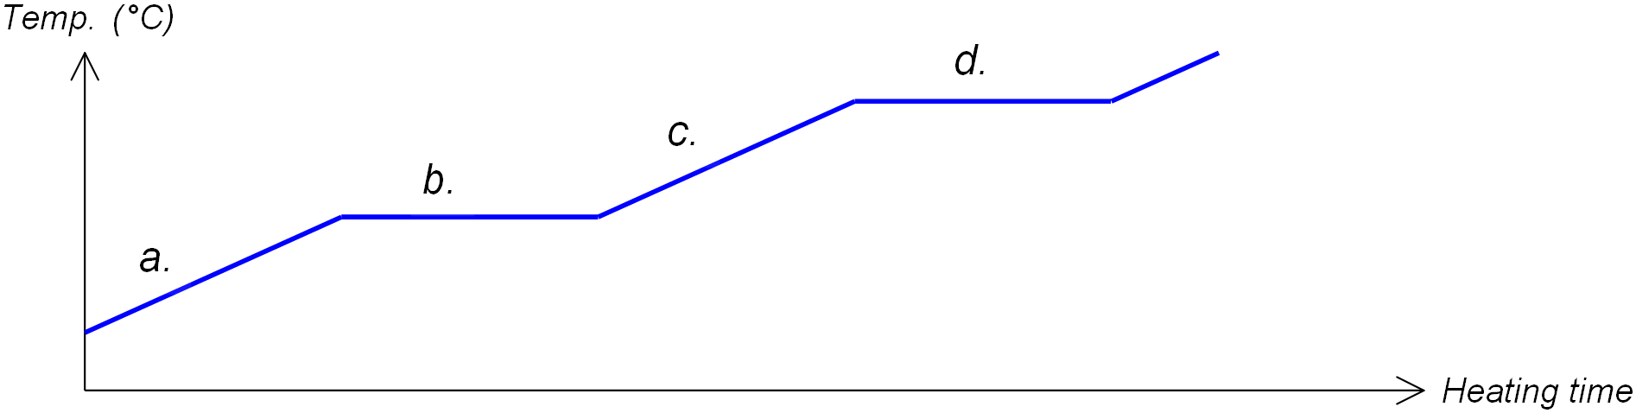

- Ethanoic (acetic) acid, CH₃COOH is classified as a weak electrolyte.
This is because:

  - Ethanoic acid is not soluble in water at room temperature.
  - Ethanoic acid does not form ions.
  - Ethanoic acid ionises to a very small extent.
  - Ethanoic acid does not have sufficient delocalised electrons.

- Which of the following statements best describes a liquid-vapour equilibrium in a closed container?
  - The rate of evaporation is faster than condensation
  - Only evaporation is occurring
  - The rate of evaporation is equal to the rate of condensation
  - The rate of evaporation is less than the rate of condensation

- The table below show the vapour pressure of several substances at 20°C. Of these substances, which would boil at this temperature if the atmospheric pressure was 100 kPa?

Water | 2.3 kPa
Propanol | 2.4 kPa
Ethanol | 5.83 kPa
Acetaldehyde | 98.7 kPa
Butane | 220 kPa
Formaldehyde | 435.7 kPa

  - Water & Propanol
  - Butane & Formaldehyde
  - Ethanol & Butane
  - Acetaldehyde & Butane

- Which of the following substances ionises when dissolved in water?
  - Glucose (C₆H₁₂O₆)
  - Hydrogen bromide (HBr)
  - Sodium carbonate (Na₂CO₃)
  - Carbon Dioxide (CO₂)

- Which of the following is NOT an example of a homogeneous substance?

  - carbon dioxide gas
  - a solution of copper(11 ) sulphate
  - molten lead
  - a mixture of oil and water

- Consider the following two solutions:

Solution 1 consists of 1 mol L⁻¹ iron (III) sulfate and Solution 2 consists of 1 mol L⁻¹ sodium sulfate.

Which of the following statements is TRUE?

- The [SO₄²⁻] in Solution 1 is 1.5 times the [SO₄²⁻] in Solution 2.
- The [Na⁺] is Solution 2 is equal to the [Fe³⁺] in Solution 1.
- The [Na⁺] in Solution 2 is half the [SO₄²⁻] in Solution 1.
- The [Fe³⁺] in Solution 1 is equal to the [SO₄²⁻] in Solution 2.

End of Multiple Choice Section

ANSWER BOOKLET

Name: Teacher:

Score: /50
Multiple choice section

Instructions
For each question, shade the box to indicate your answer.
If you make a mistake, place a cross through the box and shade your new answer.
If in the event you change back to your original answer, cross out your second selection and circle the first answer

1. | a | b | c | d
2. | a | b | c | d
3. | a | b | c | d
4. | a | b | c | d
5. | a | b | c | d
6. | a | b | c | d
7. | a | b | c | d
8. | a | b | c | d
9. | a | b | c | d
10. | a | b | c | d
11. | a | b | c | d
12. | a | b | c | d
13. | a | b | c | d
14. | a | b | c | d
15. | a | b | c | d

Calculations and Short Answer section: Answer in the space provided
Numerical answers rounded to 2 decimal places.

- Calculate the number of moles of the following: [3 marks]

  - Copper in 17 g of copper metal

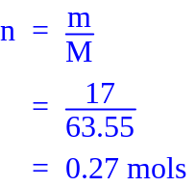

  - Nitrogen atoms in 17 moles of ammonium nitride
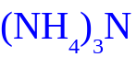

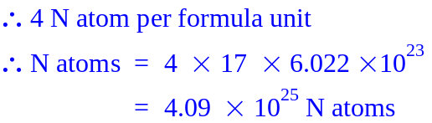

  - Chlorine atoms in 2·7099 × 10²⁴ molecules of chlorine gas
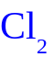

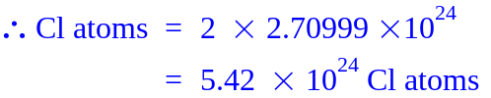

- Which of the following substances contains the greatest percentage by mass of calcium?
Calcium chloride, Calcium nitrate, Calcium phosphate. [4 marks]

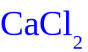 | 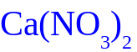
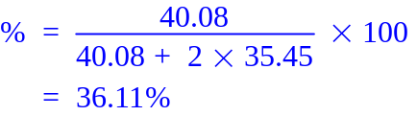 | 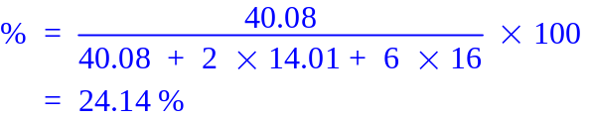
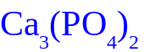
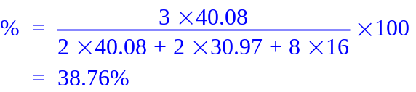

Greatest %

- In a 10·0 g sample of ammonium hydrogenphosphate [(NH₄)₂HPO₄], how many moles of the following species are present?

  - Ammonium hydrogenphosphate formula units [2 marks]
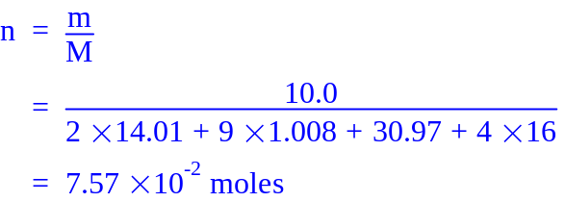
  - Ammonium ions [1 mark]

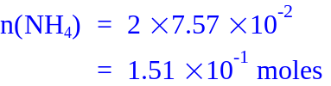
  - Hydrogenphosphate ions [1 mark]

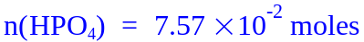
  - Hydrogen atoms [1 mark]

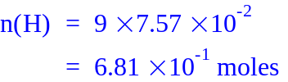

- Monazite is a rare earth mineral that contains Cerium (IV) oxide [CeO₂]. Cerium is a metal that is used in the production of many electronic devices (flat screen televisions in particular). In Australia Monazite contains 43·7% CeO₂
  - Calculate the percentage of cerium in cerium (IV) oxide. [2 marks]

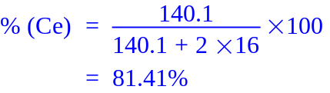

  - What mass of monazite must be refined to produce 500 kg of pure cerium metal? [2 marks]

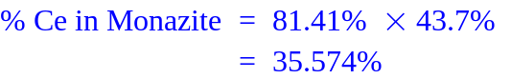

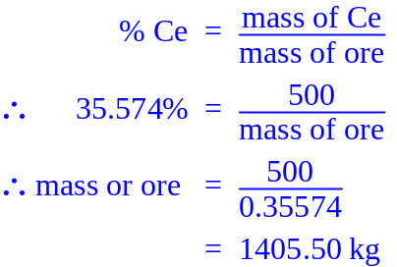

- For an investigation a student ordered 200 mL of 0·14 mol L⁻¹ silver nitrate. However when their equipment tray arrived they discovered they had been given 200 mL of 7·00 mol L⁻¹ silver nitrate.

Calculate the volume of concentrated solution required to make up the diluted solution ordered by the student. [2 marks]

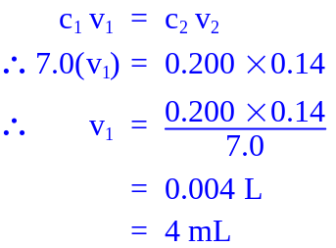

- Copper (II) chloride [CuCl₂] is light brown when anhydrous and is green when hydrated.
  - Explain the meaning of the words anhydrous and hydrated. [2 marks]

Anhydrous – no water molecules in the crystal lattice
Hydrated – water molecules in the crystal lattice

A 25·57 g sample of the hydrated copper (II) chloride-x-water was heated and found to have a mass of 20·17 g when dehydrated.
  - Calculate the percentage by mass of water in the original hydrated sample. [2 marks]

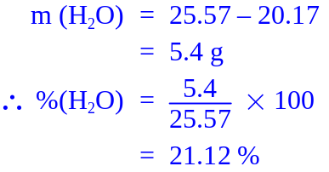

  - Find the number of moles of water and CuCl₂ in the hydrated sample. [2 marks]

 | CuCl₂ |  | H₂O
m = | 20.17 g |  | 5.4 g
M = | 63.55 + 2×35.45  =134.45 |  | 18.016
N = | 0.15 moles |  | 0.30 moles

  - State the chemical formula of the hydrated copper (II) chloride sample in the form CuCl₂.xH₂O
[2 marks]
From above ratio CuCl₂ : H₂O = 1:2

CuCl₂.2H₂O

- To prepare an oven cleaning agent, 1·08 g sodium hydroxide was dissolved in 250 mL of distilled water.
Calculate the concentration of sodium hydroxide in the oven cleaner.

  - Express your answer in g L^{–1}. [1 mark]

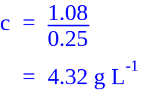

  - Express your answer in mol L⁻¹. [2 marks]
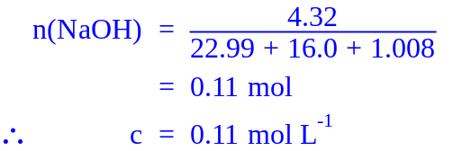

- Freezing point depression is a colligative property.
  - Upon what factor does the strength of a colligative property depend? [2 marks]

The concentration of dissolved particles in solutions (ions or molecules)

  - List two colligative properties other than freezing point depression. [2 marks]

Lowering of vapour pressure and boiling point elevation

- In an internal combustion engine gaseous fuels and oxygen gas react to release energy in the form of heat.
Use the kinetic theory of matter to explain what happens to the volume of the gases produced as the temperature of the combustion chamber increases. Include at least one diagram. [3 marks]

As temperature increases, average kinetic energy of particles increase (1), leading to and increased volume (2) (assuming pressure is constant)

Diagram -1 mark

